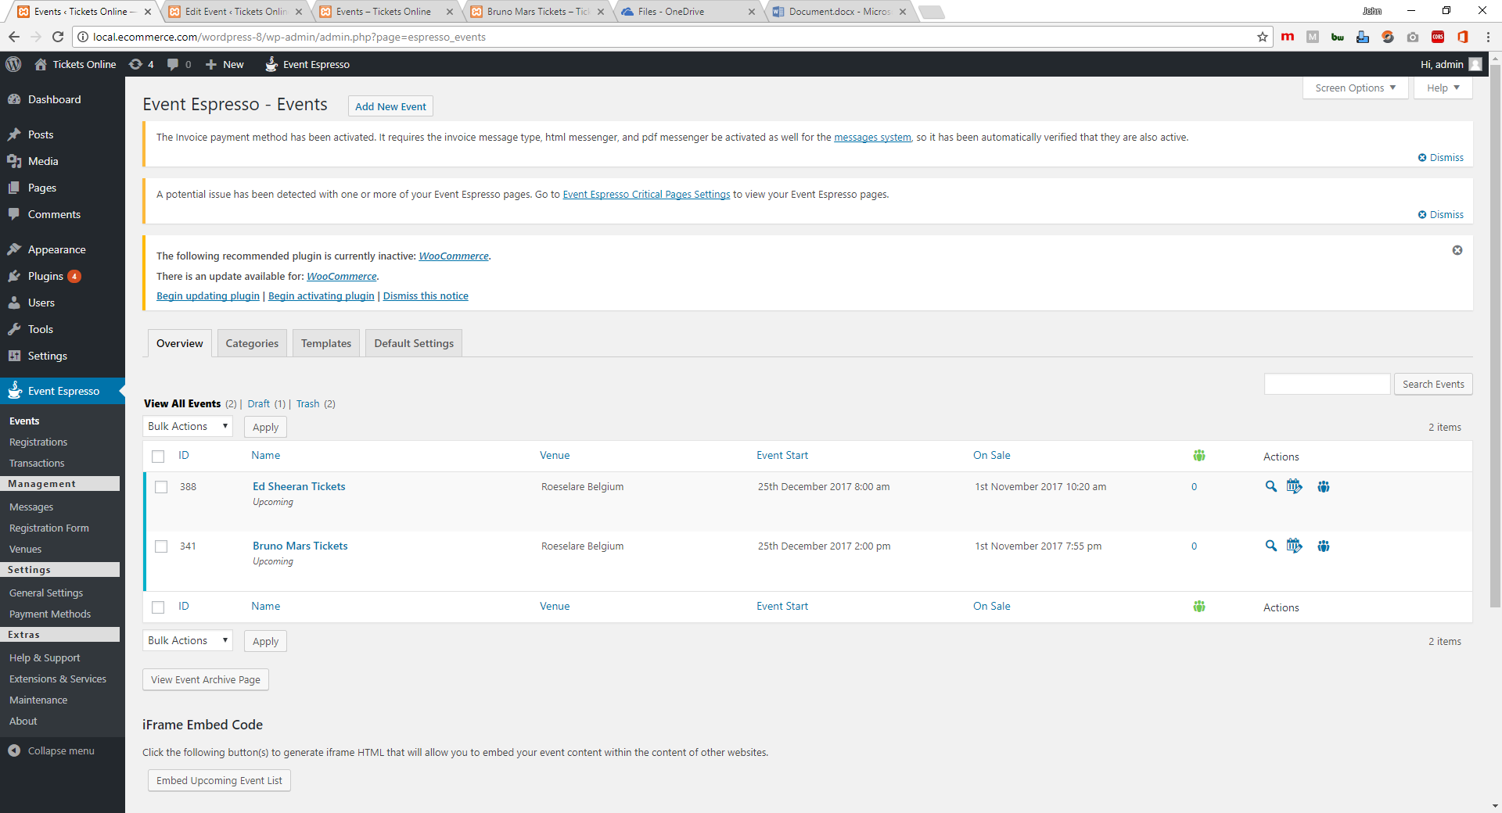

Event Espresso

1. Events : This is the page for creating New Events

Add New Event – Click to start creating events.